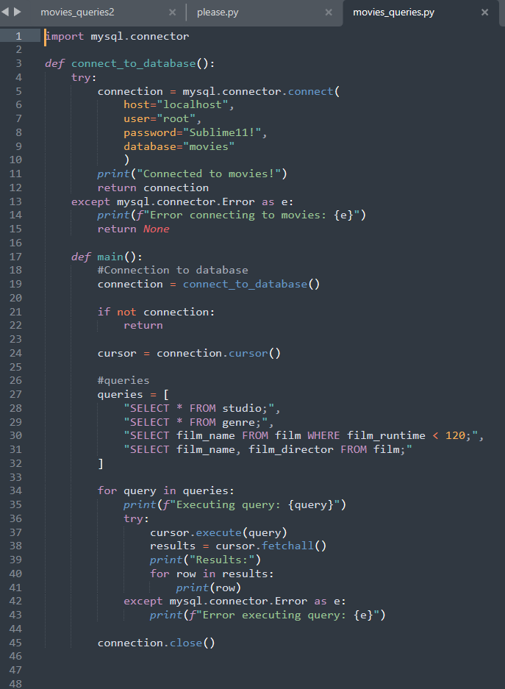

I had this printing out, then I dropped something on my laptop and deleted something from the file. I have been going back and forth trying to figure out what I deleted or added. I have also tried a few times to recreate the file and have been unable to make it work. I will be connecting with a tutor to see what is wrong.